

Project Report

Beauty Of Beaches



Group Members

Inzimam Ul Haq

Haroon Afridi

Masharib Najam

Zayed Rashid Ghouri

Contents

………………………Introduction…………………………

1. Definition of the problem………………………………………4
2. Requirement Analysis…………………………………………
3. Design Phase…………………………………………………………..
4. Source Code……………………………………………………………..
5. User Guide…………………………………………………………………

Introduction

Welcome to Beauty Of Beaches. This website provides the information about famous beaches in the world. The information is categorized zone wise (NORTH, SOUTH, WEST and EAST).

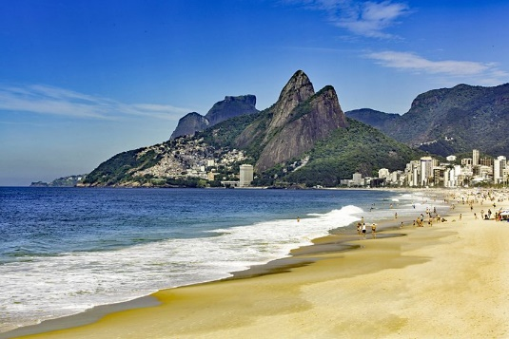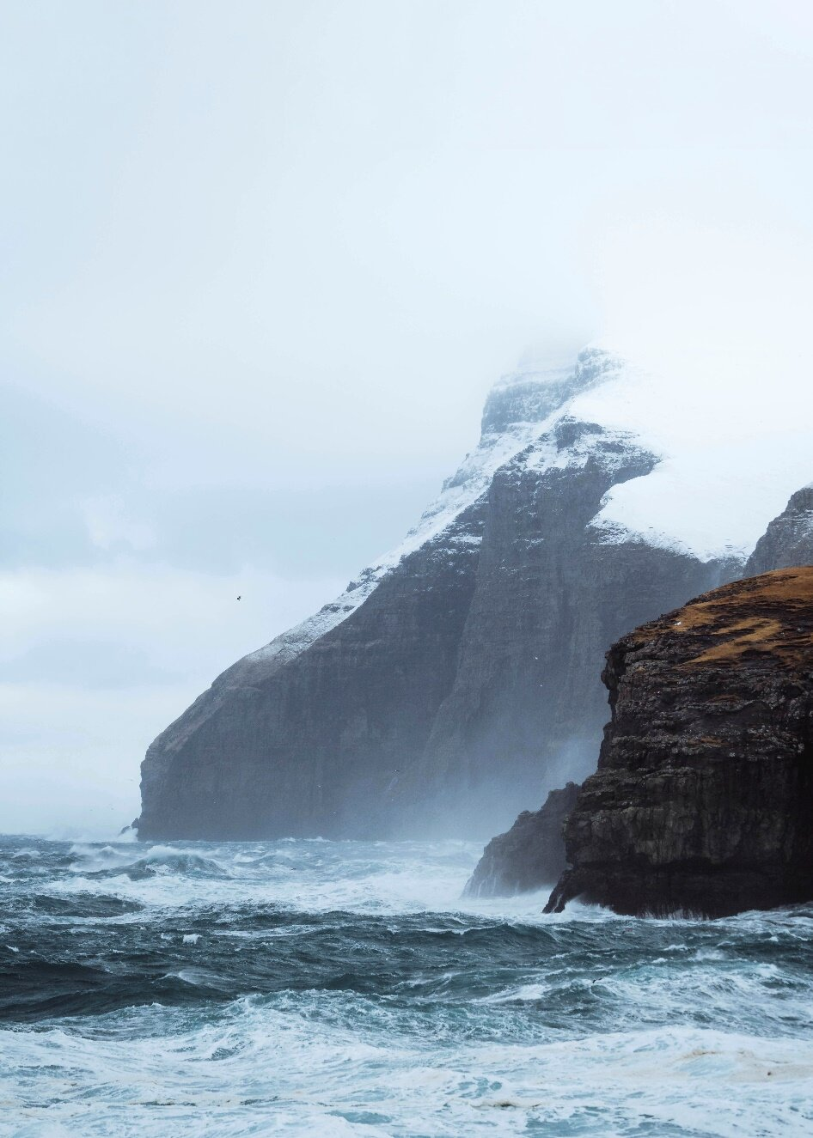

1. Definition of the Problem

The most important economic benefit of beaches is that they serve as a tourist attraction site. Tourism is the largest economic activity in the world and it not only earns countries foreign revenue, but also acts as a large employer for the local population. “BeautyOfBeaches” is the website that provide the information about famous beaches in the world. The information is categorized zone wise (NORTH, SOUTH, WEST and EAST).

1. Requirement Analysis

* The Top of the Page presented with a suitable logo and various famous images of respective beaches.
* The site contain the links to navigate through any zone for the information.
* Links of beaches can be categorized by zone wise like (East, North, West and South)
* Gallery is added for viewing different images.
* Feedback is allowed to enter by the viewer
* Site map, Gallery, about us, Queries link, Contact us link is added.
* About Us and Contact Us: This menu option display Email id, address, and contact number of the organization.
* The advertise section of bus, flights is included for reaching the places.

1. Design Phase
   1. Home page navigation bar with Dropdown images

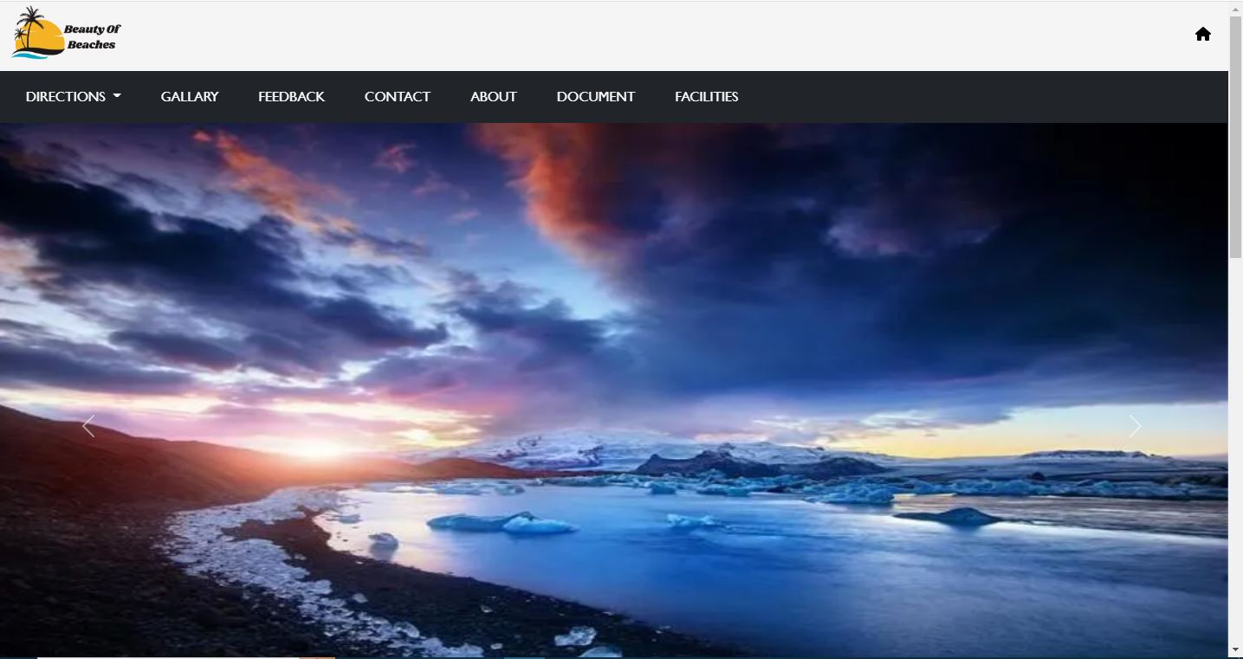

3.2 Home page main content

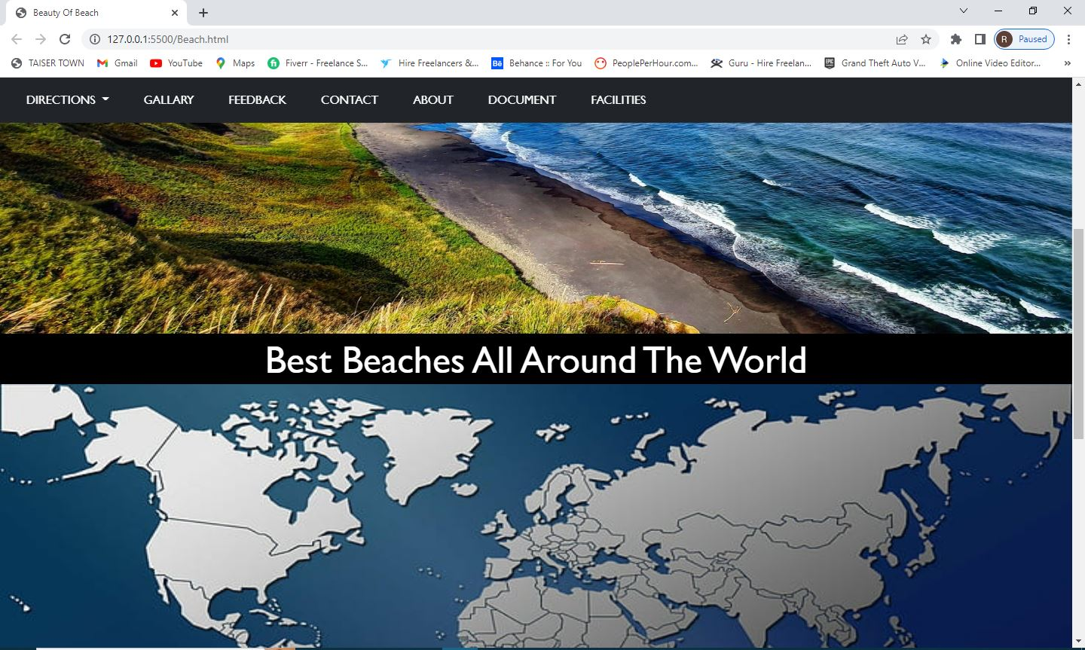

3.3 About Us Page

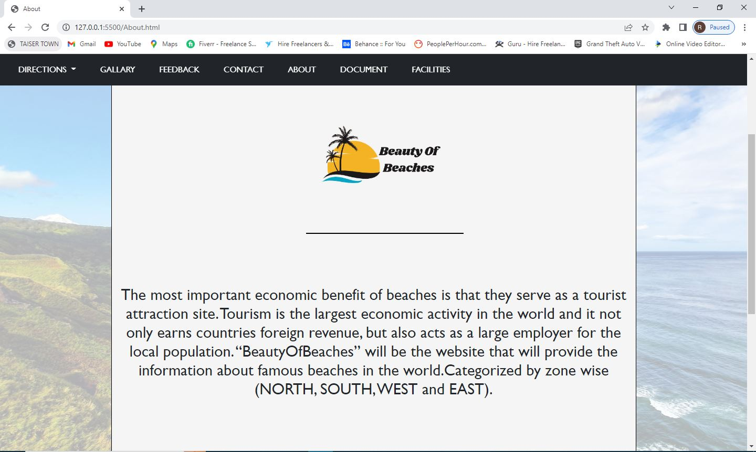

3.4 East

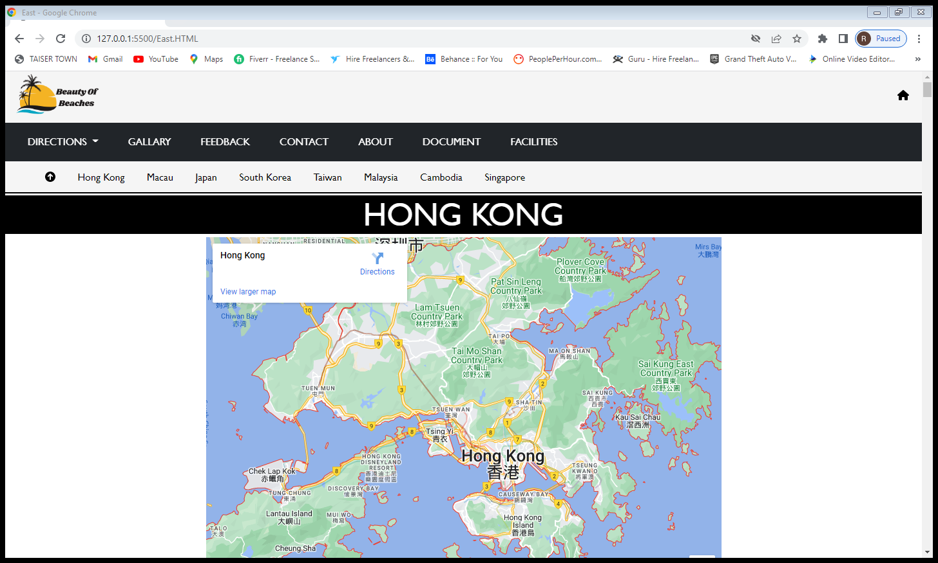

3.4 West

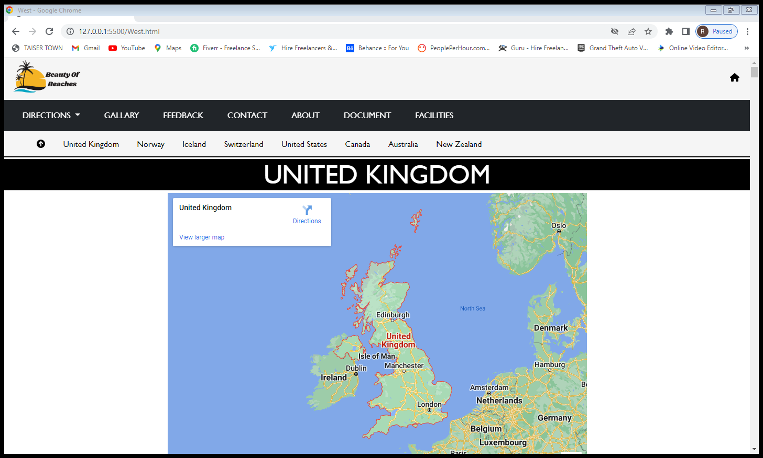

3.5 North

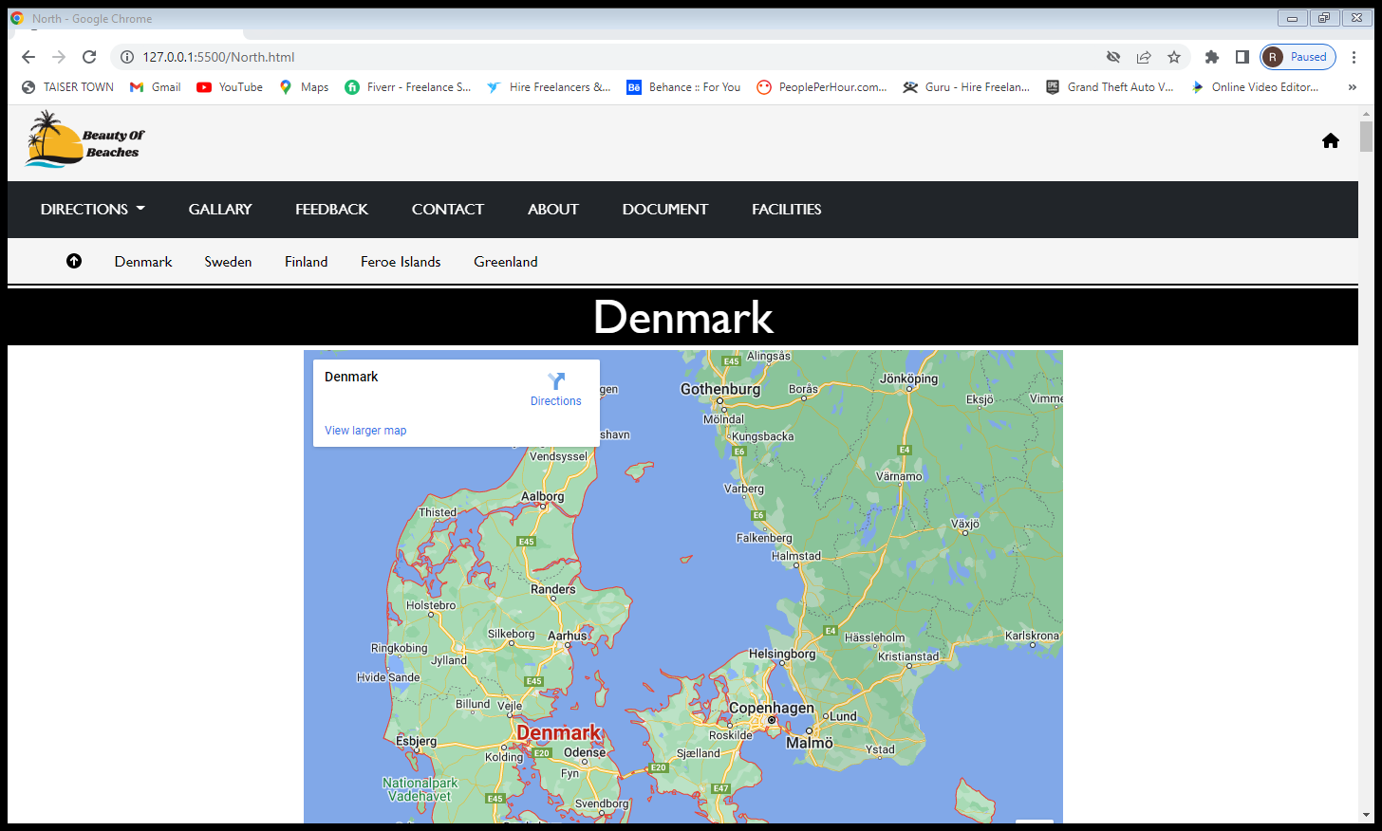

3.6 South

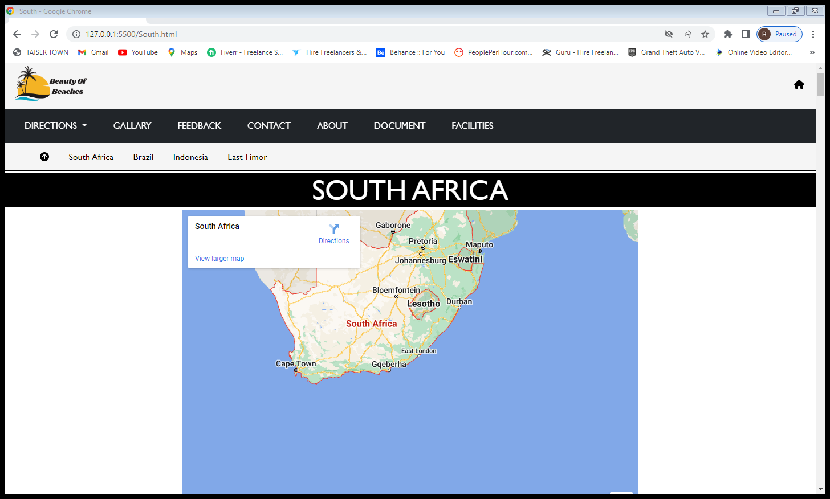

3.7 Footer

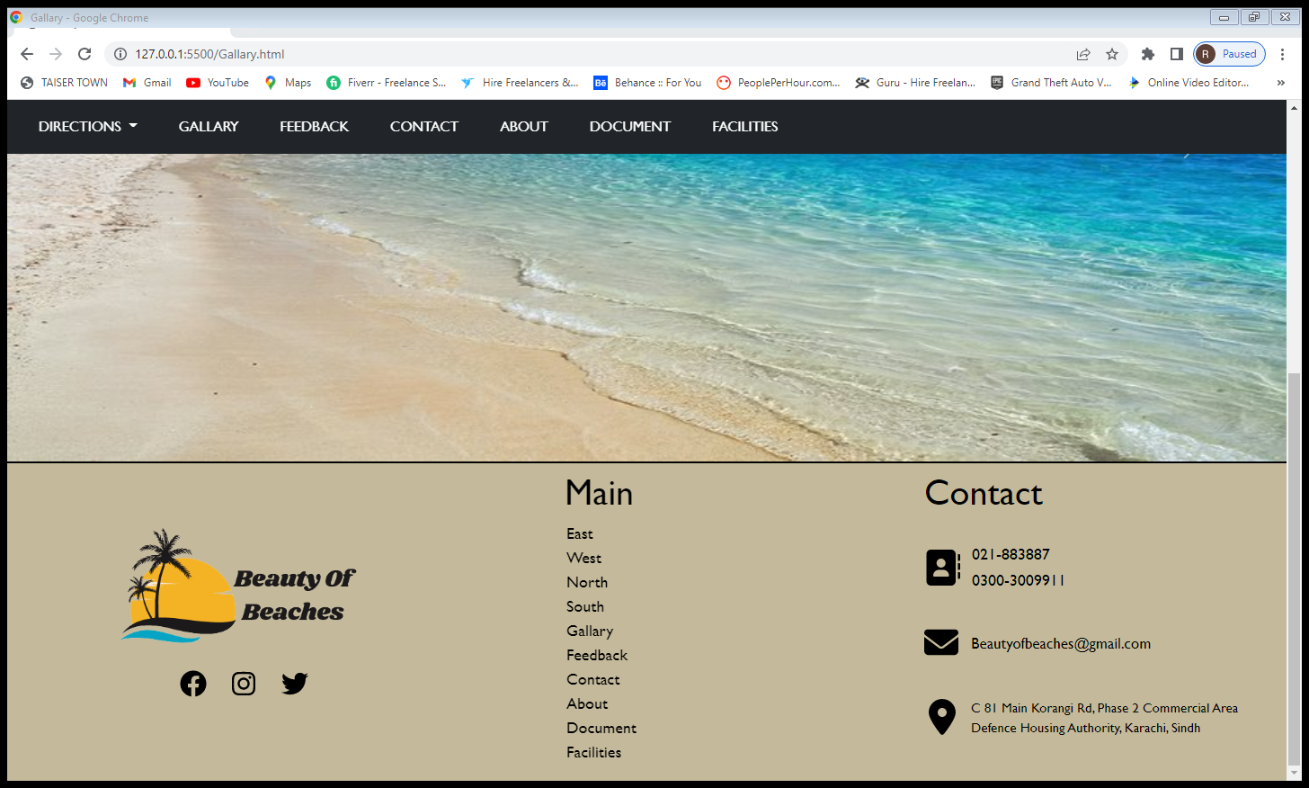

3.8 Contact Form with validation

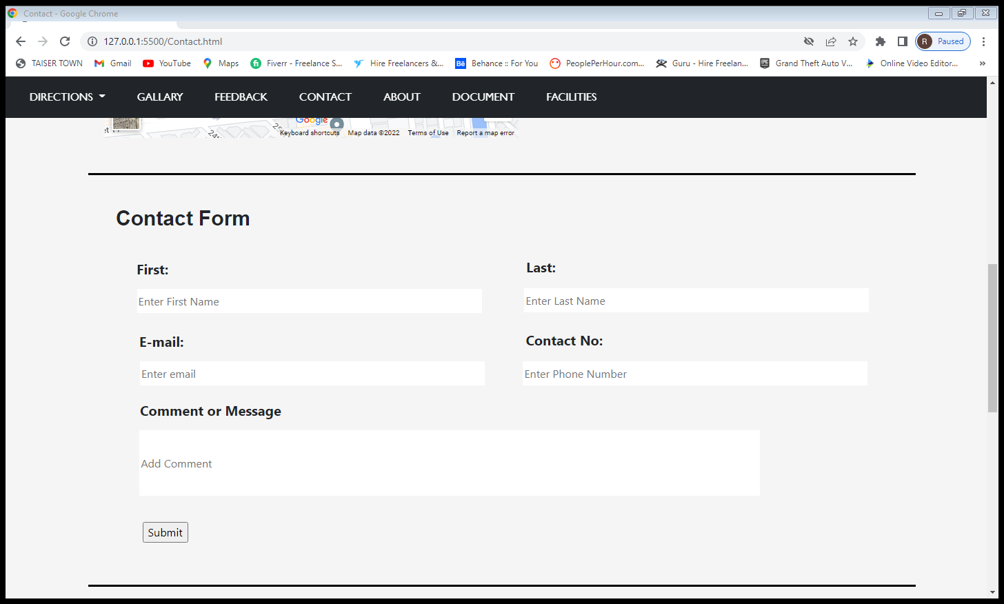

1. Source Code

4.1 Navigation bar

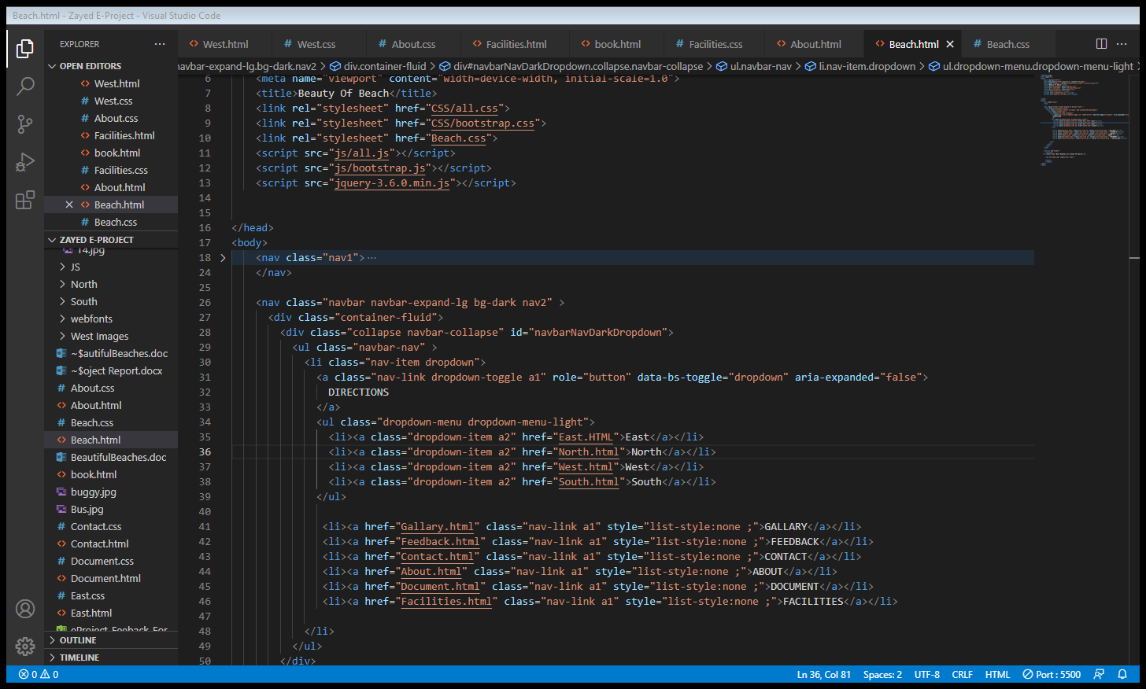

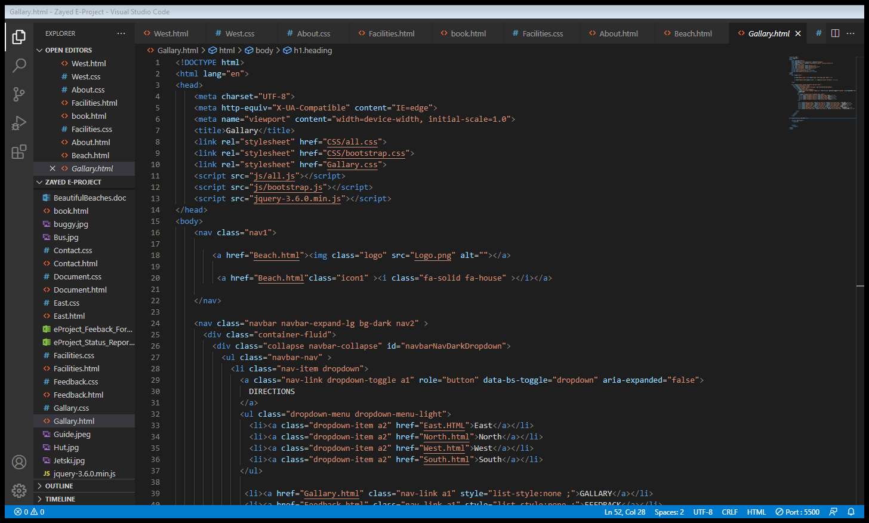4.2 Gallery Section

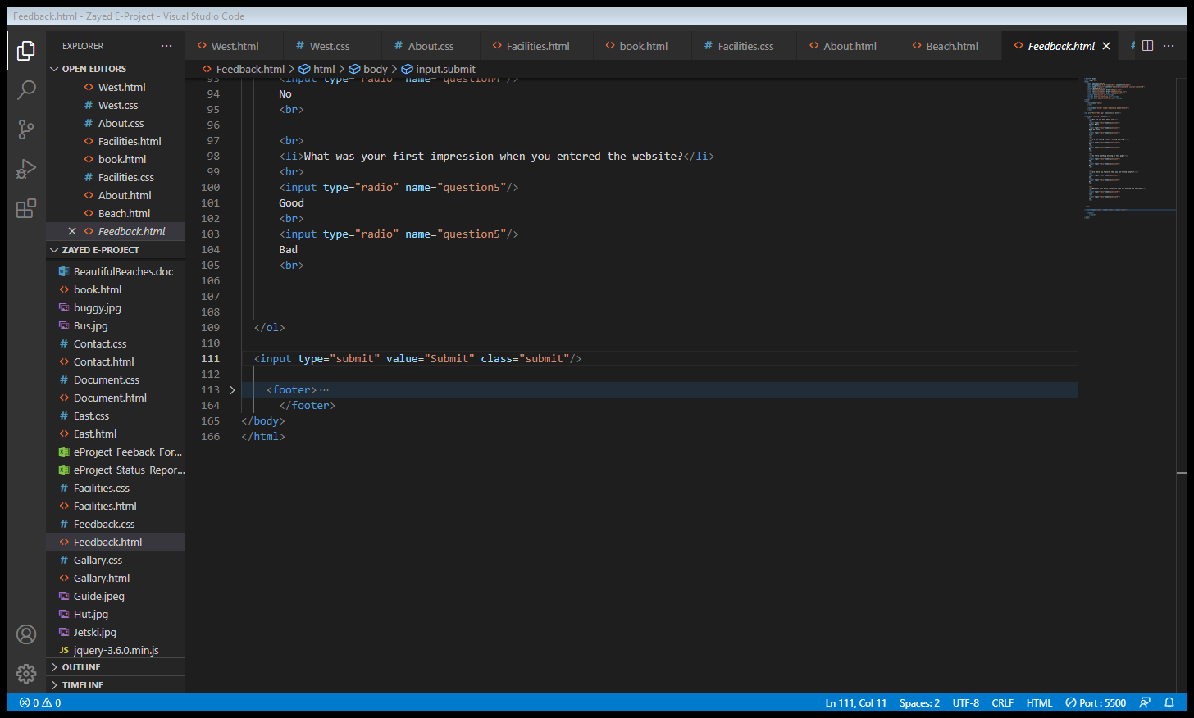4.3 Feed Back Page

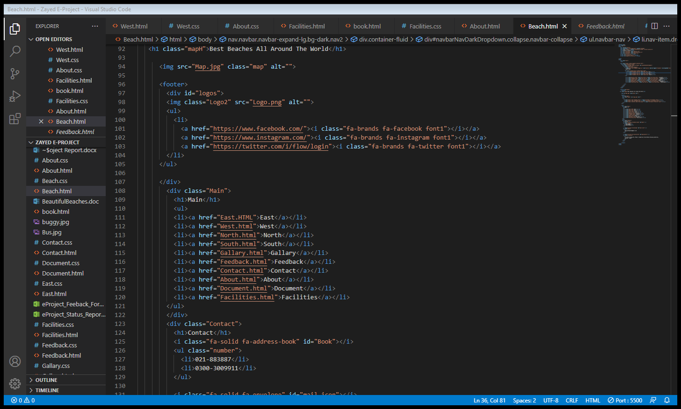4.4 Footer

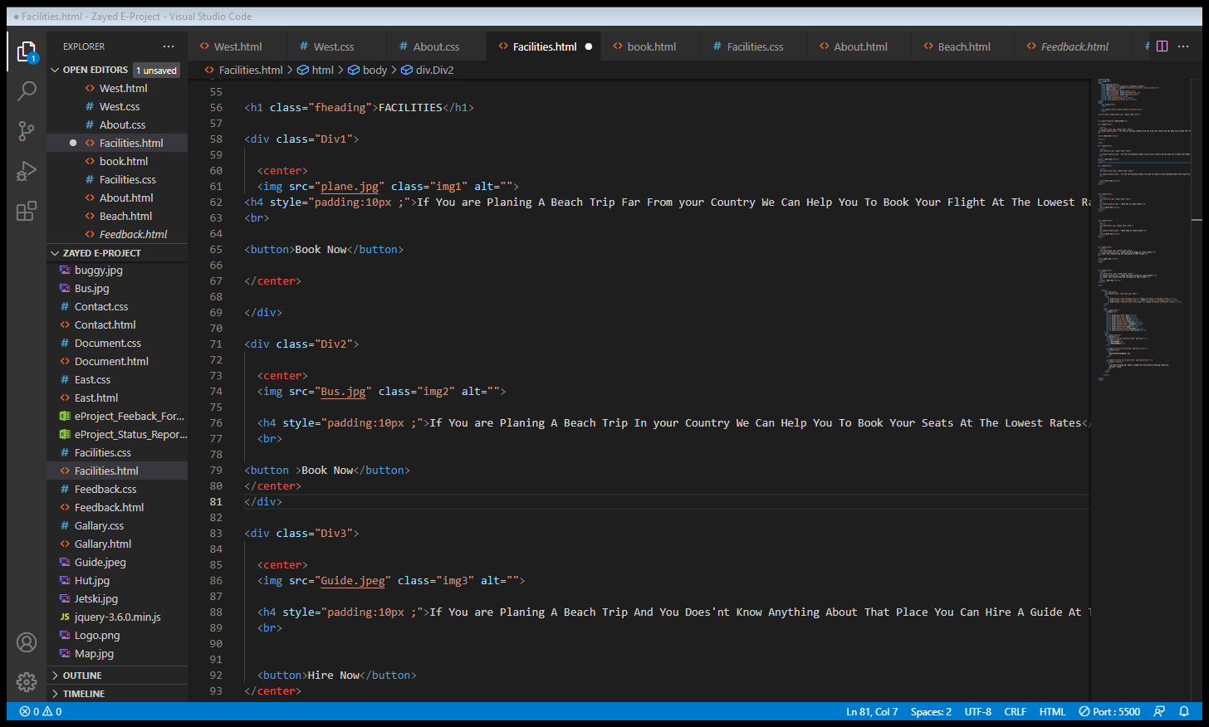4.5 Facilities

1. User Guide

**Hard Ware**

* Intel Core i3/i5 Processor or higher
* 8 GB RAM or above
* Color SVGA
* 500 GB Hard Disk space
* Mouse
* Keyboard

**Soft Ware**

* Frontend: HTML5, CSS, Bootstrap, JavaScript, jQuery,
* Data Store: JSON files or TXT files

5.2 Technology used

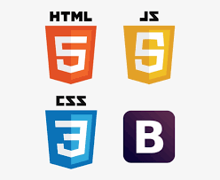



Thank You

